FACULTY EVALUATION
Programme Name: SBVP ALUMNI MASTERCLASS - SCALE Module I Online Zambia (20th April 2026 - 24th April 2026)
Session: Reflection of SEP Learning
Faculty Name: Benard Chege
No. of Respondents: 8
No. of Participants: 10
Evaluation Parameter | (%) Individual Score | (%) Programme Average
Punctuality (Commencement and Completion of Sessions) | 80 | 75
How well do you understand the core concepts presented? | 88 | 72
Rate your confidence in applying the new skills learnt | 90 | 72
Degree of Faculty preparedness for the sessions | 92 | 76
Content and methodology of the program | 95 | 77
Quality of class and group discussions | 92 | 72
The information presented in the course is relevant to my work (ministry) | 95 | 76
Average scores | 90 | 74

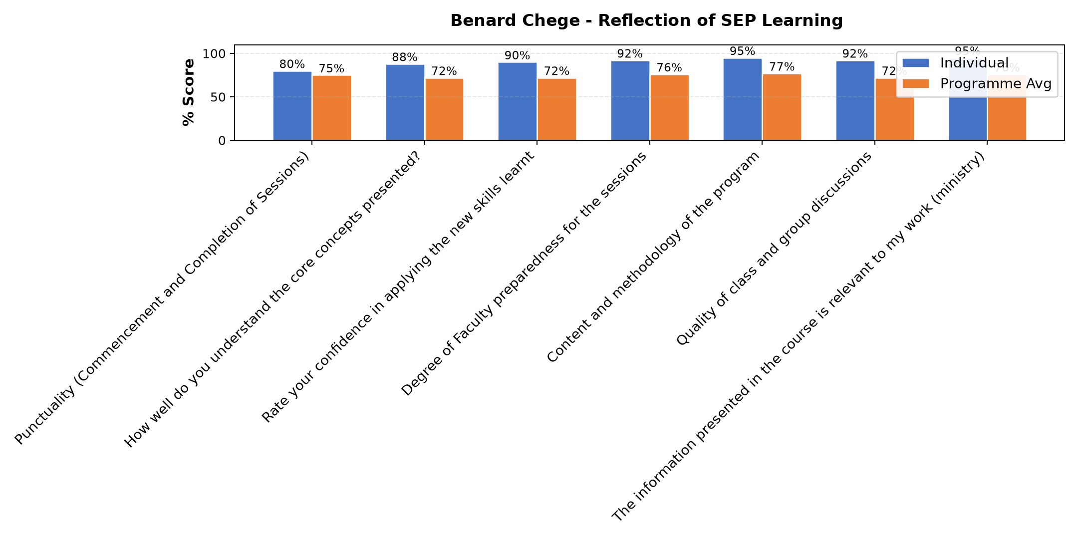

Comments & Feedback
- • Family members or neighbors dont believe social enterprises work, or dont think youths with disabilities can run a business and also you can make the product, but you dont know who will buy or how to reach them.
- • Capital resources like finances, vehicle and difficult of the beneficiaries to change their mind set
- • Family members or the community dont believe social enterprise work, or dont think youths with disabilities can run a business. You can also make a product, but you dont know who will buy or how to reach them.
- • Network and I cannot hear the teacher very well
- • I am currently not at the Social enterprise, but missioned outside the country. I will give support to the ones on the ground
- • Not sure if now
- • There are no barriers to prevent me. The sessions were very educative.
SUBMITTED THROUGH:
SBS Evaluation Automation System

